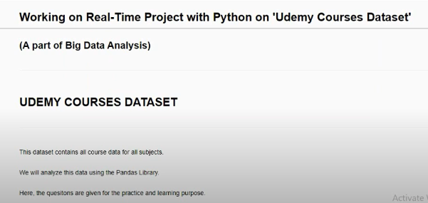

1. What are all different subjects for which Udemy is offering courses ?

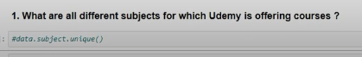

2. Which subject has the maximum number of courses ?

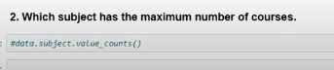

3. Show all the courses which are Free of Cost.

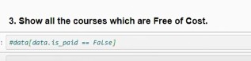

4. Show all the courses which are paid.

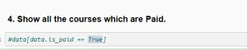

5. Which are Top Selling Courses ?

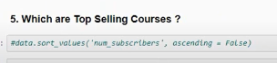

6. Which are least Selling Courses ?

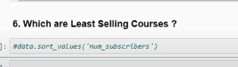

7. Show all courses of Graphic Design where the price is below 100 ?

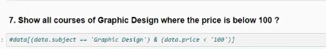

8. List out all the courses that are related with "Python".

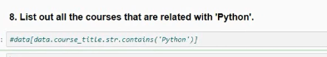

9. What are courses that published in year 2015 ?

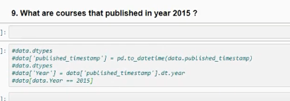

10. What are the Max. Number of Subscribers for Each Level of courses ?

